Support Vector Machine

Introduction
I guess by now you would’ve accustomed yourself with linear regression and logistic regression algorithms. If not, I suggest you have a look at them before moving on to support vector machine. Support vector machine is another simple algorithm that every machine learning expert should have in his/her arsenal. Support vector machine is highly preferred by many as it produces significant accuracy with less computation power. Support Vector Machine, abbreviated as SVM can be used for both regression and classification tasks. But, it is widely used in classification objectives.

What is Support Vector Machine?
The objective of the support vector machine algorithm is to find a hyperplane in an N-dimensional space(N — the number of features) that distinctly classifies the data points.
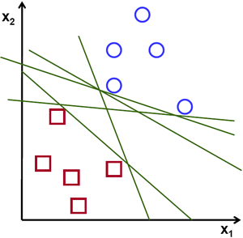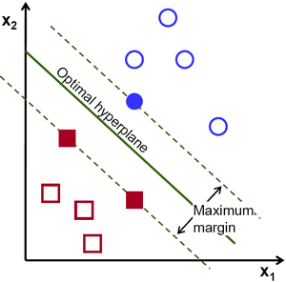Possible hyperplanes
To separate the two classes of data points, there are many possible hyperplanes that could be chosen. Our objective is to find a plane that has the maximum margin, i.e the maximum distance between data points of both classes. Maximizing the margin distance provides some reinforcement so that future data points can be classified with more confidence.
Hyperplanes and Support Vectors
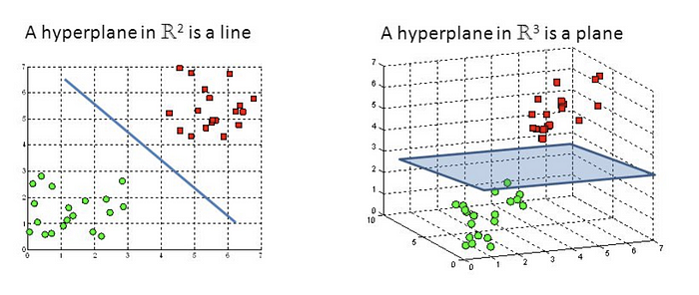
Hyperplanes in 2D and 3D feature space
Hyperplanes are decision boundaries that help classify the data points. Data points falling on either side of the hyperplane can be attributed to different classes. Also, the dimension of the hyperplane depends upon the number of features. If the number of input features is 2, then the hyperplane is just a line. If the number of input features is 3, then the hyperplane becomes a two-dimensional plane. It becomes difficult to imagine when the number of features exceeds 3.
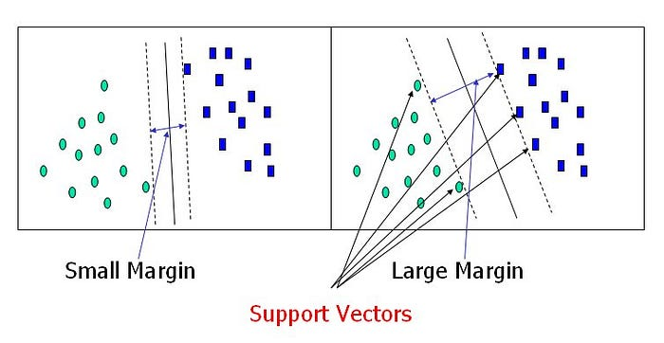

Support Vectors
Support vectors are data points that are closer to the hyperplane and influence the position and orientation of the hyperplane. Using these support vectors, we maximize the margin of the classifier. Deleting the support vectors will change the position of the hyperplane. These are the points that help us build our SVM.

Large Margin Intuition
In logistic regression, we take the output of the linear function and squash the value within the range of [0,1] using the sigmoid function. If the squashed value is greater than a threshold value(0.5) we assign it a label 1, else we assign it a label 0. In SVM, we take the output of the linear function and if that output is greater than 1, we identify it with one class and if the output is -1, we identify is with another class. Since the threshold values are changed to 1 and -1 in SVM, we obtain this reinforcement range of values([-1,1]) which acts as margin.

Cost Function and Gradient Updates
In the SVM algorithm, we are looking to maximize the margin between the data points and the hyperplane. The loss function that helps maximize the margin is hinge loss.
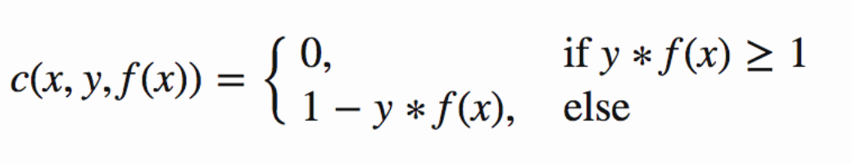
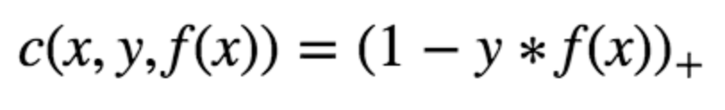
Hinge loss function (function on left can be represented as a function on the right)
The cost is 0 if the predicted value and the actual value are of the same sign. If they are not, we then calculate the loss value. We also add a regularization parameter the cost function. The objective of the regularization parameter is to balance the margin maximization and loss. After adding the regularization parameter, the cost functions looks as below.
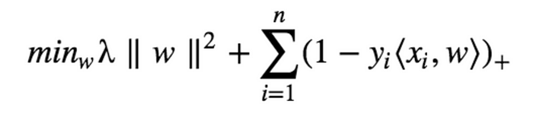
Loss function for SVM
Now that we have the loss function, we take partial derivatives with respect to the weights to find the gradients. Using the gradients, we can update our weights.
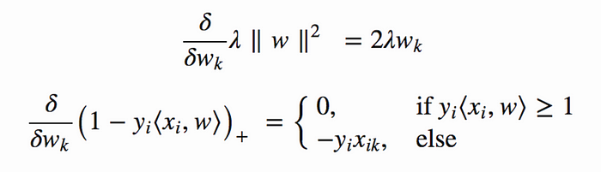
Gradients
When there is no misclassification, i.e our model correctly predicts the class of our data point, we only have to update the gradient from the regularization parameter.
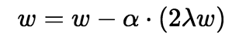
Gradient Update — No misclassification
When there is a misclassification, i.e our model make a mistake on the prediction of the class of our data point, we include the loss along with the regularization parameter to perform gradient update.
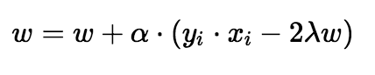
Gradient Update — Misclassification
SVM Implementation in Python
The dataset we will be using to implement our SVM algorithm is the Iris dataset. You can download it from this link.
Since the Iris dataset has three classes, we will remove one of the classes. This leaves us with a binary class classification problem.
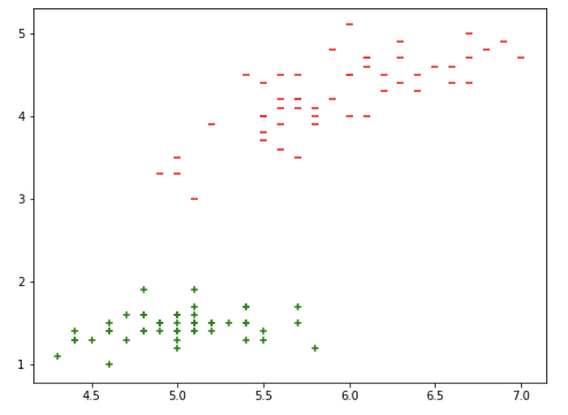
Visualizing data points
Also, there are four features available for us to use. We will be using only two features, i.e Sepal length and Petal length. We take these two features and plot them to visualize. From the above graph, you can infer that a linear line can be used to separate the data points.
We extract the required features and split it into training and testing data. 90% of the data is used for training and the rest 10% is used for testing. Let’s now build our SVM model using the numpy library.
α(0.0001) is the learning rate and the regularization parameter λ is set to 1/epochs. Therefore, the regularizing value reduces the number of epochs increases.
We now clip the weights as the test data contains only 10 data points. We extract the features from the test data and predict the values. We obtain the predictions and compare it with the actual values and print the accuracy of our model.
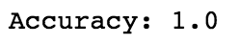
Accuracy of our SVM model
There is another simple way to implement the SVM algorithm. We can use the Scikit learn library and just call the related functions to implement the SVM model. The number of lines of code reduces significantly too few lines.

Conclusion
Support vector machine is an elegant and powerful algorithm. Use it wisely :)

